**Mission Control Center**

From Wikipedia, the free encyclopedia

*"Mission control" redirects here. For other uses, see Mission control (disambiguation).*

|  |  |  |
| --- | --- | --- |
|  |  |  |
| International Space Station control rooms in Russia and America. | | |

A **mission control center** (**MCC**) is an entity that manages aerospace vehicle flights, usually from the point of lift-off until the landing or the end of the mission. A staff of flight controllers and other support personnel monitor all aspects of the mission using telemetry, and send commands to the vehicle using ground stations. Personnel supporting the mission from an MCC can include representatives of the attitude control system, power, propulsion, thermal, attitude dynamics, orbital operations and other subsystem disciplines. The training for these missions usually falls under the responsibility of the flight controllers, typically including extensive rehearsals in the MCC.

**NASA's Mission Control Center**

Main article: Christopher C. Kraft Jr. Mission Control Center

Prior to liftoff missions are controlled from the Launch Control Center (LCC) located at NASA's Kennedy Space Center on Merritt Island, Florida. Responsibility for the booster and spacecraft remains with the LCC until the booster has cleared the launch tower, when responsibility is handed over to the NASA's Mission Control Center (MCC-H), at the Lyndon B. Johnson Space Center, in Houston. The MCC also manages the U.S.

**RKA Mission Control Center**

Main article: RKA Mission Control Center

The Mission Control Center of the Russian Federal Space Agency (Russian: Центр управления полётами), also known by its acronym ЦУП ("TsUP") is located in Korolyov, near the RKK Energia plant. It contains an active control room for the ISS. It also houses a memorial control room for the Mir where the last few orbits of Mir before it burned up in the atmosphere are shown on the display screens.

**Beijing Aerospace Command and Control Center**

Main article: Beijing Aerospace Command and Control Center

**Beijing Aerospace Command and Control Center** is a command center for the Chinese space program which includes the Shenzhou missions. The building is inside a complex nicknamed Aerospace City. The city is located in a suburb northwest of Beijing.

**Other significant mission control centers**

* Mobile Servicing System Control and Training at Saint-Hubert, Quebec, Canada. Supports Canadarm2 robotics operations.
* The Columbus Control Center (Col-CC) at the German Aerospace Center (DLR) in Oberpfaffenhofen, Germany. It is the mission control center for the European *Columbus* research laboratory at the International Space Station.
* The ATV Control Centre (ATV-CC) is located at the Toulouse Space Centre (CST) in Toulouse, France. It is the mission control center for the European Automated Transfer Vehicles, that regularly resupply ISS.
* JEM Control Center and the HTV Control Center at the Tsukuba Space Center (TKSC) in Tsukuba, Japan manages operations aboard JAXA's Kibo ISS research laboratory and the resupply flights of the H-II Transfer Vehicle. JAXAs satellite operations are also based here.
* The Jet Propulsion Laboratory (JPL), in pasadena ca. manages all of NASAs unmanned spacecraft outside earths orbit.
* goddard spaceflight center, greenbalt maryland, mission control for the hubble telescope
* European Space Operations Centre (ESOC) responsible for ESAs satellites and space probes.
* Boeing Satellite Development Center (SDC) Mission Control Center[2] in El Segundo, California, US.
* Lockheed Martin A2100 Space Operations Center (ASOC)[3] in Newtown, Pennsylvania, US.
* Space Systems/Loral Mission Control Center[4] in Palo Alto, California, US.
* Titov Main Test and Space Systems Control Centre, mission control center in Krasnoznamensk, Russia.
* Mercury Control Center was located on the Cape Canaveral Air Force Station and used during Project Mercury now serves as a make shift bunker if a rocket blows up.

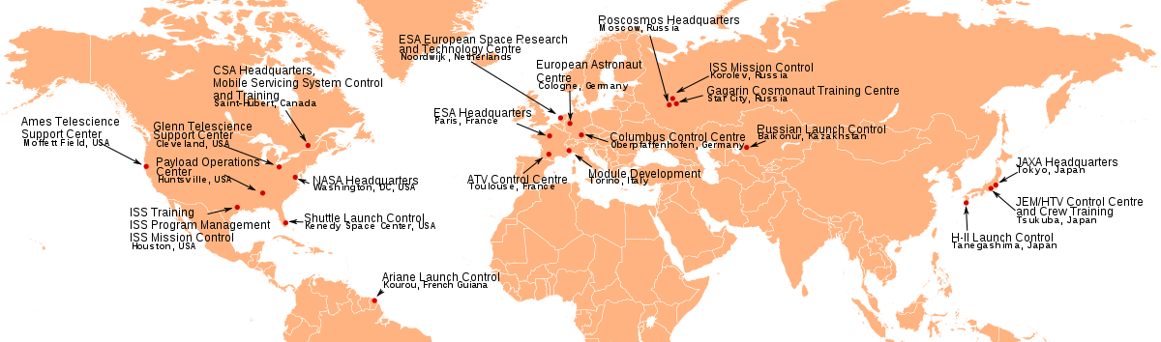

Space centers involved with the International Space Station.

* ISRO SHAR Mission Control Centre, Satish Dhawan Space Centre, Sriharikota, India.

This page was last modified on 23 March 2013 at 06:50.